ADES CA2 Set Up Guide

**Install Applications**

1. Link to download pages
   1. Visual Studio Code: <https://code.visualstudio.com/>
   2. Node.js: <https://nodejs.org/en/download/>
   3. MySQL Workbench: <https://dev.mysql.com/downloads/workbench/>
   4. Install all of them

**Setup MySQL Workbench**

1. Open MySQL Workbench and click new query Text

   Description automatically generated on the top left.
2. Then copy this code in an click run A picture containing text

   Description automatically generated, you have created the database and tables!

CREATE DATABASE IF NOT EXISTS `ca2-project` /*!40100 DEFAULT CHARACTER SET utf8mb4 COLLATE utf8mb4_0900_ai_ci */ /*!80016 DEFAULT ENCRYPTION='N' */;

USE `ca2-project`;

-- MySQL dump 10.13 Distrib 8.0.22, for Win64 (x86_64)

--

-- Host: localhost Database: ca2-project

-- ------------------------------------------------------

-- Server version 8.0.22

/*!40101 SET @OLD_CHARACTER_SET_CLIENT=@@CHARACTER_SET_CLIENT */;

/*!40101 SET @OLD_CHARACTER_SET_RESULTS=@@CHARACTER_SET_RESULTS */;

/*!40101 SET @OLD_COLLATION_CONNECTION=@@COLLATION_CONNECTION */;

/*!50503 SET NAMES utf8 */;

/*!40103 SET @OLD_TIME_ZONE=@@TIME_ZONE */;

/*!40103 SET TIME_ZONE='+00:00' */;

/*!40014 SET @OLD_UNIQUE_CHECKS=@@UNIQUE_CHECKS, UNIQUE_CHECKS=0 */;

/*!40014 SET @OLD_FOREIGN_KEY_CHECKS=@@FOREIGN_KEY_CHECKS, FOREIGN_KEY_CHECKS=0 */;

/*!40101 SET @OLD_SQL_MODE=@@SQL_MODE, SQL_MODE='NO_AUTO_VALUE_ON_ZERO' */;

/*!40111 SET @OLD_SQL_NOTES=@@SQL_NOTES, SQL_NOTES=0 */;

--

-- Table structure for table `nanoids`

--

DROP TABLE IF EXISTS `nanoids`;

/*!40101 SET @saved_cs_client = @@character_set_client */;

/*!50503 SET character_set_client = utf8mb4 */;

CREATE TABLE `nanoids` (

`id` int NOT NULL AUTO_INCREMENT,

`SessionID` varchar(45) DEFAULT NULL,

`OwnerID` varchar(45) DEFAULT NULL,

`SIDStarted` int DEFAULT '0',

PRIMARY KEY (`id`),

UNIQUE KEY `SessionID_UNIQUE` (`SessionID`),

UNIQUE KEY `OwnerID_UNIQUE` (`OwnerID`)

) ENGINE=InnoDB AUTO_INCREMENT=26 DEFAULT CHARSET=utf8mb4 COLLATE=utf8mb4_0900_ai_ci;

/*!40101 SET character_set_client = @saved_cs_client */;

--

-- Dumping data for table `nanoids`

--

LOCK TABLES `nanoids` WRITE;

/*!40000 ALTER TABLE `nanoids` DISABLE KEYS */;

INSERT INTO `nanoids` VALUES (1,'FU1TNL4T1M','XEQRMKRK1M',0),(2,'UV1CD4K9JJ','E2D0NSFWMW',0),(3,'KLGV805CVI','8DK4ZMM9HN',0),(4,'HZ3BECGKNT','UKL2YSCYJV',0),(5,'K17W8TEXW0','4K0N4R2VNF',0),(6,'55TJ1OIY57','DBLK8J3M2G',0),(7,'BZK1MSNYPG','0RXN10RZ54',0),(8,'HVDN4NBRM7','TLII87PAWQ',0),(9,'GPNN4QYYTW','DCBM9IKB11',0),(10,'NEFQ1YKS45','5SNFUZU8SO',0),(11,'SKS6YHMY3E','31VUVM4YT2',0),(12,'LZIIG47XV5','K2AFQQ8THW',1),(13,'9NVGVCNNDJ','EVVORDCD4S',0),(14,'JUYMIX8WB3','2BAQK7WFZ1',0),(15,'YHHO6OZSTZ','K65UNNTNDU',0),(16,'Z2CFDTFANG','DXTW4ZWCKF',0),(17,'FDFUJR0RIG','HTXF7V9R75',0),(18,'PI0L6TBG5J','BK8EKD7UW5',1),(19,'PV2CHUO8OA','4H94ZNSTTU',1),(20,'P7DIPZIMTN','7VOHQJ49YE',0),(21,'4TFSOK3N2D','GBS4449OAZ',0),(22,'Q3NJG61A81','MSVFYPVXAQ',1),(23,'SAYKPNPQTZ','K20MSAZF6T',1),(24,'A72NLVNRPB','U0EFEYP63C',1),(25,'02ZZ6A027S','7N9U8LYK4G',1);

/*!40000 ALTER TABLE `nanoids` ENABLE KEYS */;

UNLOCK TABLES;

--

-- Table structure for table `questions`

--

DROP TABLE IF EXISTS `questions`;

/*!40101 SET @saved_cs_client = @@character_set_client */;

/*!50503 SET character_set_client = utf8mb4 */;

CREATE TABLE `questions` (

`id` int NOT NULL AUTO_INCREMENT,

`sessionID` varchar(45) DEFAULT NULL,

`question` varchar(100) DEFAULT NULL,

`answer` varchar(100) DEFAULT NULL,

PRIMARY KEY (`id`),

KEY `SessionID` (`sessionID`),

CONSTRAINT `SessionID` FOREIGN KEY (`sessionID`) REFERENCES `nanoids` (`SessionID`) ON DELETE CASCADE ON UPDATE CASCADE

) ENGINE=InnoDB AUTO_INCREMENT=7 DEFAULT CHARSET=utf8mb4 COLLATE=utf8mb4_0900_ai_ci;

/*!40101 SET character_set_client = @saved_cs_client */;

--

-- Dumping data for table `questions`

--

LOCK TABLES `questions` WRITE;

/*!40000 ALTER TABLE `questions` DISABLE KEYS */;

INSERT INTO `questions` VALUES (1,'SAYKPNPQTZ','send something',NULL),(2,'SAYKPNPQTZ','send something 1',NULL),(3,'SAYKPNPQTZ','send something 2',NULL),(4,'SAYKPNPQTZ','send something 3',NULL),(5,'SAYKPNPQTZ','asd',NULL),(6,'SAYKPNPQTZ','i want to finish',NULL);

/*!40000 ALTER TABLE `questions` ENABLE KEYS */;

UNLOCK TABLES;

/*!40103 SET TIME_ZONE=@OLD_TIME_ZONE */;

/*!40101 SET SQL_MODE=@OLD_SQL_MODE */;

/*!40014 SET FOREIGN_KEY_CHECKS=@OLD_FOREIGN_KEY_CHECKS */;

/*!40014 SET UNIQUE_CHECKS=@OLD_UNIQUE_CHECKS */;

/*!40101 SET CHARACTER_SET_CLIENT=@OLD_CHARACTER_SET_CLIENT */;

/*!40101 SET CHARACTER_SET_RESULTS=@OLD_CHARACTER_SET_RESULTS */;

/*!40101 SET COLLATION_CONNECTION=@OLD_COLLATION_CONNECTION */;

/*!40111 SET SQL_NOTES=@OLD_SQL_NOTES */;

-- Dump completed on 2021-08-08 13:49:52

**Setup Instructions**

**Clone repository**

1. Open your browser and go to this link: <https://github.com/ADES-FSP/ca2-linus_marcus_junhui>
   1. Go to the green button “Code” and copy the HTTPS link.
   2. Go back to Visual Studio code and on the very left, click on source control.
   3. Click clone repository and paste the link into it and click enter.

* 1. Go to databaseConfig.js and on line 25 you will see password, change it to the password you set for the MySQL Workbench. E.g., password: “put your password here”

**Install dependencies**

1. Go to the top, click terminal and then new terminal. It should appear at the bottom of your screen.
2. Type “npm install nanoid” without the “” in the terminal.
3. Type “npm install cors” without the “” in the terminal.
4. Type “npm install express” without the “” in the terminal.
5. Type “npm install mysql” without the “” in the terminal.
6. Type “npm install nodemon” without the “” in the terminal
7. Go to the very left side of visual studio code and click Extensions, then search for live server and install this:

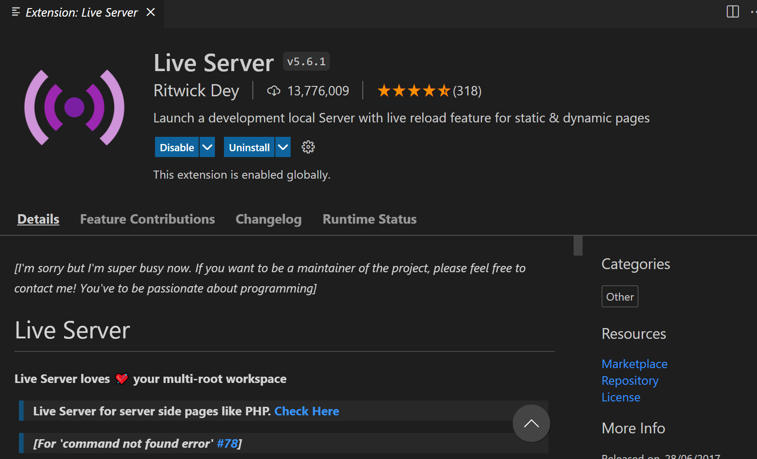

**Run Application**

1. Go to the top, click terminal and then new terminal. It should appear at the bottom of your screen.
2. Type “cd backend” without the “”
3. Type “node app.js” without the “”, you should see “listening on Port 8080”
4. Your backend in now started!
5. Right click on index.html, session and question.html separately and click on “Open with live server” it will open 3 pages in your browser.

**Congratulations! You have setup the application successfully!**

**Basic Code Organisation**

1. The APIs are in the app.js file
2. The backend logic is in the data.js file
3. The website sends the HTTP requests from the index.js, questions.js and session.js files (fetch and url)
4. The website assets are in the website folder
5. The websites application logic is in the files index.js, questions.js and session.js files

**End of documentation**